Town Builder
Initial Design Document by Alejandro Elias
Gameplay
The gameplay will be similar to an incremental game primarily, but it will also have some aspects of city building games. The game will consist of the main play area where the player can build and passively collect resources to further grow their city. The sub-areas will be present for players to more actively gain resources.
These sub-areas will go hand in hand with the main screen, as an example, the player will be able to go inside a mine to tap for resources that replenish after a certain amount of time. The aim of these areas is for the player to have an active input when gathering resources, to provide a small break from building and to provide more resources to the player so they don’t feel like their only option is to wait.
On the other hand, the layout and the management of the buildings in your town will have an impact on the currency earned passively through idling. This currency will also be necessary to construct more buildings. The city will be divided into a grid so it's easier to place buildings in a more organized manner, which in turn will also let the buildings check for adjacent units. This will be beneficial to the player, as some buildings will boost the income generated by others or have other bonuses.
To grant variety of buildings to the player, five categories of units exist. Housing, Gatherers, Farms, Refinement and Entertainment buildings. Each of these will have different requirements and interactions with each other. All buildings should be connected to roads, which can be built for a small price.
- Housing
The most basic of the buildings possible and the foundation of all cities. It will generate constant revenue and will increase the population living in the area. As in real life, not all houses are the same as some might be smaller or bigger and this will influence the amount of money generated and how much it will raise the population capacity.
- Gatherers
This unit focuses in the generation of building resources such as wood and stone. If placed near housing they may have a negative impact on the revenue generated.
- Farms
Farms will generate food, this is necessary not only to keep your population growing, but also to keep them alive and well.

- Refinement
These buildings will be necessary for progression as they will open the door to new materials used for construction and increase the yield of raw materials. As an example, while farms generate a flat food value, if that product is processed it takes longer but the food value increases considerably.
- Entertainment
Entertainment buildings can be multiple things. On one hand, parks will have an impact in all buildings surrounding it, increasing the original income by a flat or percentage-wise manner. To compensate for the ability to raise earnings, it will have to have a maintenance fee. On the other hand, more traditional entertainment buildings may provide other bonuses.
All the buildings should be able to be upgraded with different options to raise their different values, such as income, population and possibly even reduce the maintenance cost.
To give the player an extra push and another option to stay on the game, random events can happen that will give the player a bonus if they interact with it. For example, a present attached to a balloon floating across the screen. This can be the currency or a small pack of resources, maybe even premium currency if this is implemented into the game.
Goal and Prestige
The aim of the game would be to grow your city and gather resources to be able to expand to other areas where you could keep building and growing. These new areas would be different from the starting area, for example one with big bodies of water and not much land.
Another common mechanic in incremental games is the ability to reset the progress of your game while getting a bonus for the next run. The way this can be implemented into this game would be to let the player either have the option to simply reset with the click of a button or to let the player use natural disasters to clear their city and start from scratch. This would forcefully occur if the player ends their civilization by killing all their population due to lack of food or other reasons.
Monetization
Though not mandatory, the game could be easily be monetized without heavily interfering in the user experience. One of the more common ways to implement it, would be to push the player to watch ads or pay a sum of premium currency to make the construction of buildings take less time. Another use of advertising videos can also be aimed to multiply the earnings of the city for a short period of time.
The other way to tackle this is to sell resource packs for the game’s sub-areas. When you tap a vein enough that it is destroyed and it gives you the resources, the vein will have a cooldown until a new resource shows up. With the resource packs, the player will be able to refill the vein with whichever resource is accepted. A pack containing random resources could be purchased with regular and premium currency, while a pack containing specific and even more rare resources can only be acquired using premium currency.
Style
The game would be a 3D low-poly version of classic city building games. This would allow the camera to be positioned up in the air while letting the player be able to rotate the world 90 degrees.
The game setting would take place in floating islands, this allows the creation of other islands the player may aim to reach. This would also let the player terraform their island to some degree, like letting them increase the space of their building grid by adding pieces of land.
Targeting
The game would aim to be released on mobile and aims to please a casual target audience of players primarily, as the game will be mostly simple to pick up and play. However, players that are more used to city building games will be able to find some enjoyment due to the possibility to optimize the city and the interaction between units.

Similar Games
- Egg, Inc.
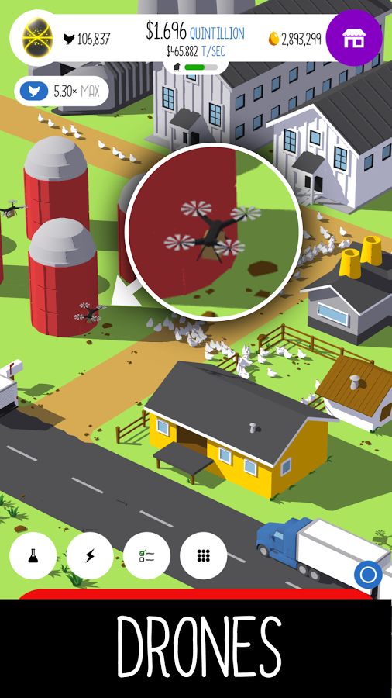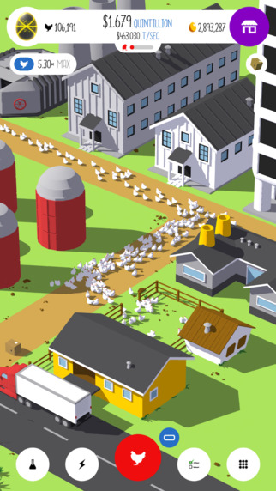
- Century City
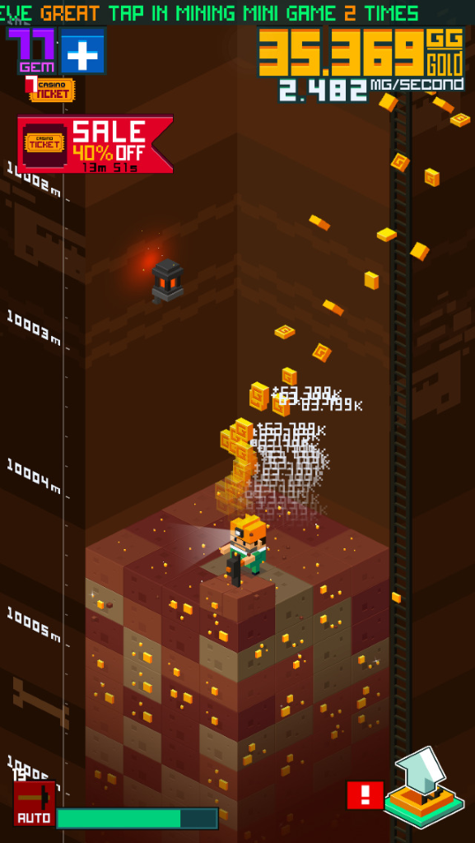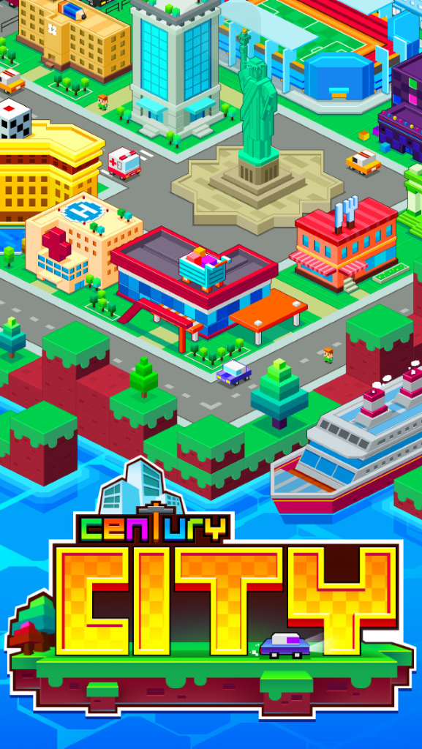

- Reactor
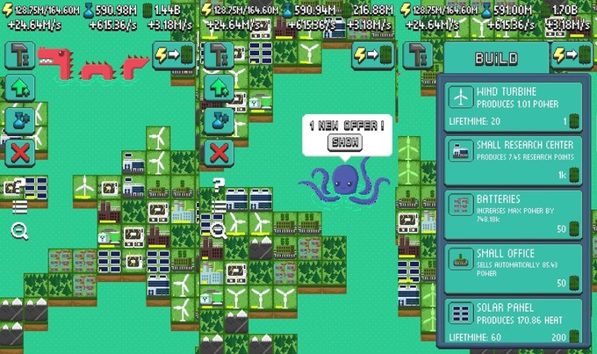
- Township
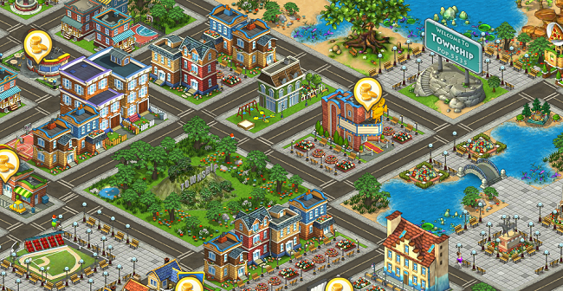

- SimCity
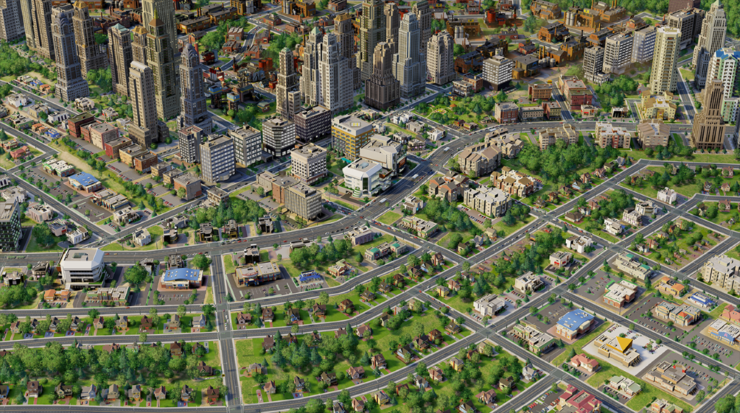
- Rise of Industry
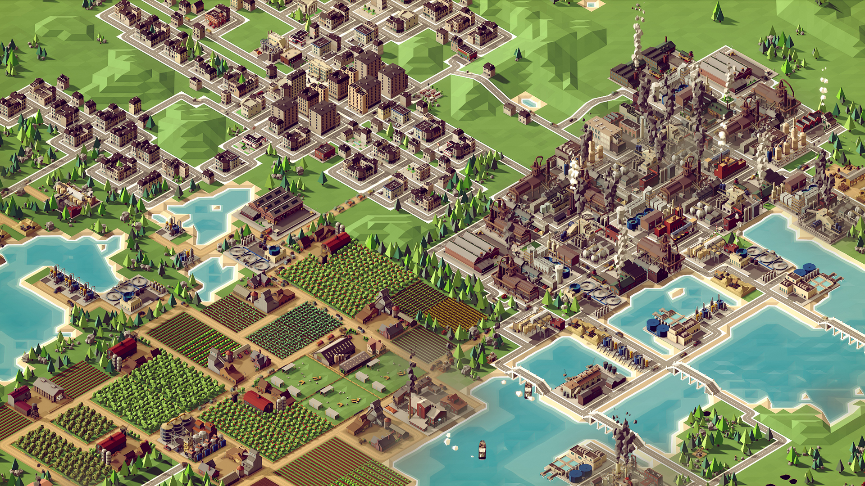

Features
Assets
- Road models
- Building models
  - Housing
  - Gatherers
  - Farm
  - Refinement
  - Entertainment
- Tile model
  - Grass tile
  - Forest tile
  - Mine tile
  - Beach tile
  - Water tile
- UI
  - City UI
    - Currency
    - Resources
    - Population
  - Sub-area UI
    - Cooldown timer
    - Resource Vein icons
  - Shop UI
    - Premium currency
    - Resource pack icon
- Balloon model
MoSCoW
Must
- Tiled grid
- Ability to build over tiles
- Housing generates income
- Gatherers and Farms generate resources
- Currency, resources and population shown on screen
- Simple sub-areas
Should
- Buildings react to buildings surrounding them
- Simple upgrades
- Random balloons with presents
- Simple sound effects
Could
- Animations
- Different variations for buildings, as to not repeat one constantly
Would Like
- Detailed and varied sound effects
- Roads have cars moving

