Vectorship - Initial Design Document
Lead Developer: Alejandro Elias

Gameplay

The player will be placed in a level, this will consist of the player's controllable spaceship (represented by a cyan triangle) and randomly spawned asteroids (represented by red square borders). The level will be a “closed environment” as it will only be what is shown in the screen and touching the borders will teleport the player to the opposite side of the map, giving the idea that it loops. The player will also be able to shoot to defend themselves and destroy asteroids.

The main goal of the player must be to destroy all the asteroids in the screen to complete the level. Each asteroid when destroyed will spawn a specific amount of smaller and faster asteroids, there are three variations of sizes which simply are referred and identified as big, medium, and small.

There are other components to the game, such as power ups and enemies. On one hand there are power ups that will assist the player as they will upgrade the ship in multiple possible ways. These have multiple “branches”, because the upgrades have been divided in categories for ease of choosing the one desired by the player, but the trade off means that the player will have to shoot the power up to cycle through the possible categories. On the other hand, enemies will follow simple routes and shoot the player when possible, the bullets shot by the enemies will also affect the power up rotation and might hinder not only in the normal play as it will make the player change it's moving patterns, but it will also may be able to affect the power ups.

As the asteroids grow smaller and faster, they give more points to the player. So it will be in the player's decision and judgement to either destroy a big asteroid and all it's smaller pieces one by one, or shoot multiple to make it harder for themselves but also earn the points in a quicker manner. Points also determine when the power ups appear, as a thousand points equal to a power up spawn randomly in the map.

Similar games:

Asteroids
Geometry Wars
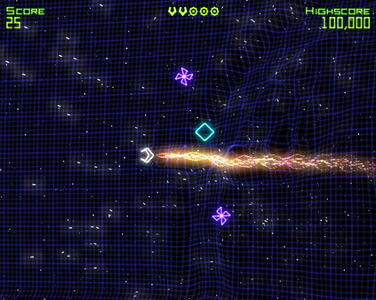

Feature List

Assets
Assets needed to be created:
- Rocket sprite
- Squares sprites that represent the asteroids, all three sizes.
- Bullet sprite
- Power up sprites, three variations
- UFO sprite
- Background
- Victory Screen background
- Game Over Screen background

Feature Extraction
- Simple models for the ship and asteroids
- Simple controls, such as rotation and propulsion
- Simple collision detection
- Variable parameters for the asteroids such as directional speed
- Basic background
- Spawned power up after set amount of points
- GUI to select a power ups when picked up
- Bullet upgrades such as multi shot and bullet speed
- Defensive upgrades such as a shield or an extra life
Possible features
- Colour coded asteroids or enemies
- Explosive asteroids or enemies

MoSCoW

Must
- Controllable main ship
- If the ship goes off bounds, must be teleported to the other side of the screen
- Moving asteroids
Should
- Asteroids should split when shot
- Basic collision between asteroids and player
- Asteroids should spawn with random rotation and movement
- Power ups
- Score system
- Basic upgrades after ‘X’ amount of points
Could
- Basic animations for asteroids and ship
- Timer
- Life counter
- UFO as enemy
Would Like
- Table with high scores
- Sound effects
- Multiple types of enemies
- Animations for enemies

Design Sketches
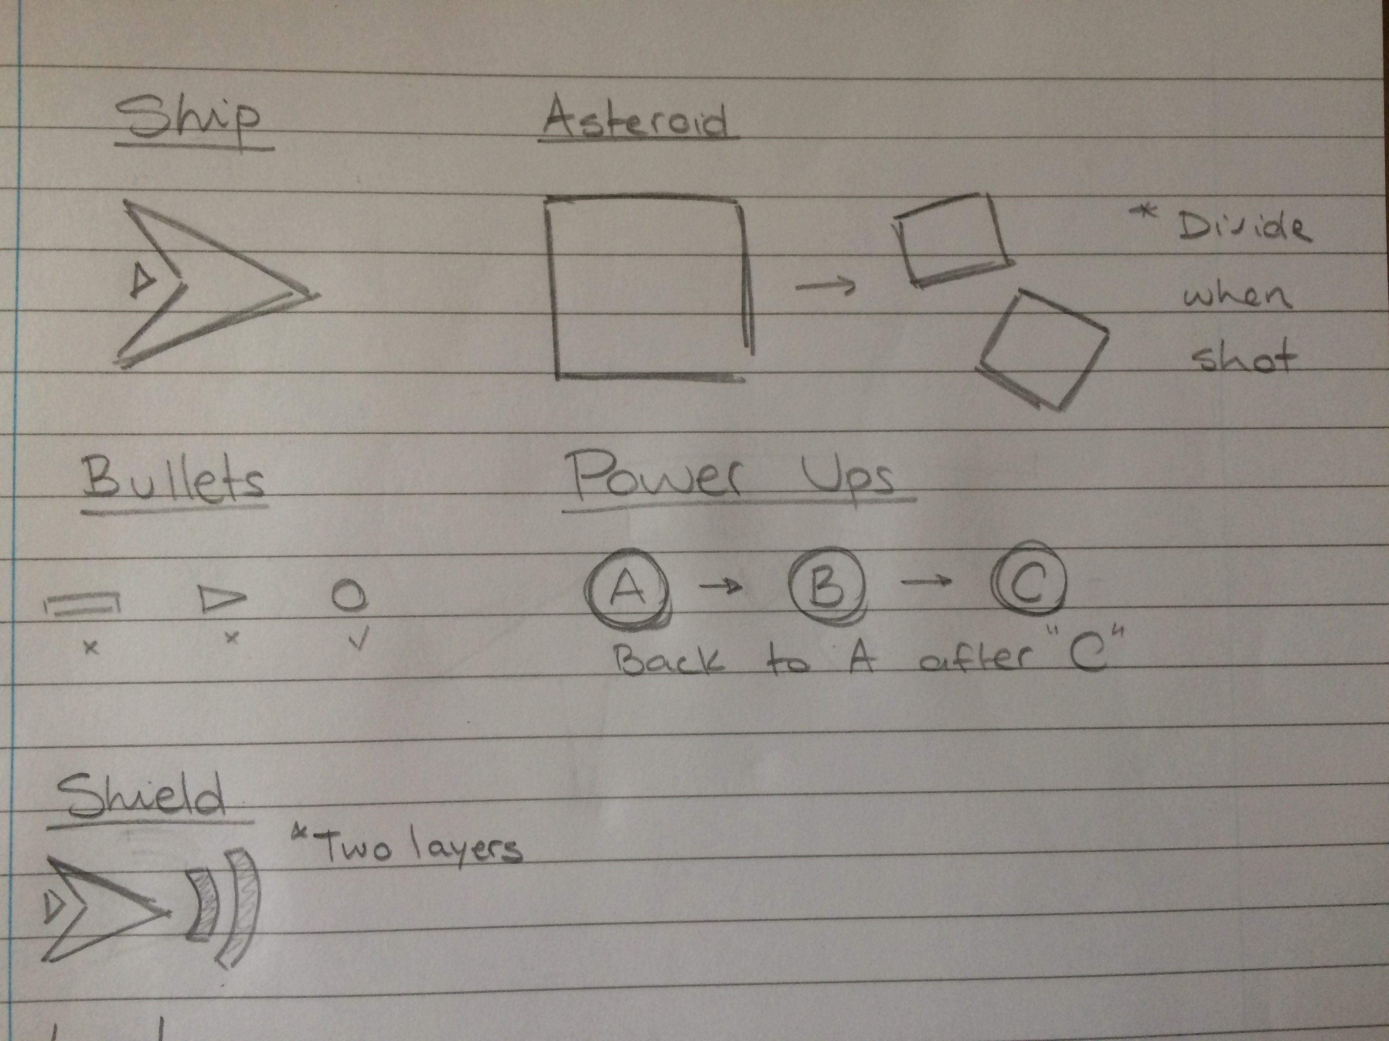
Assets

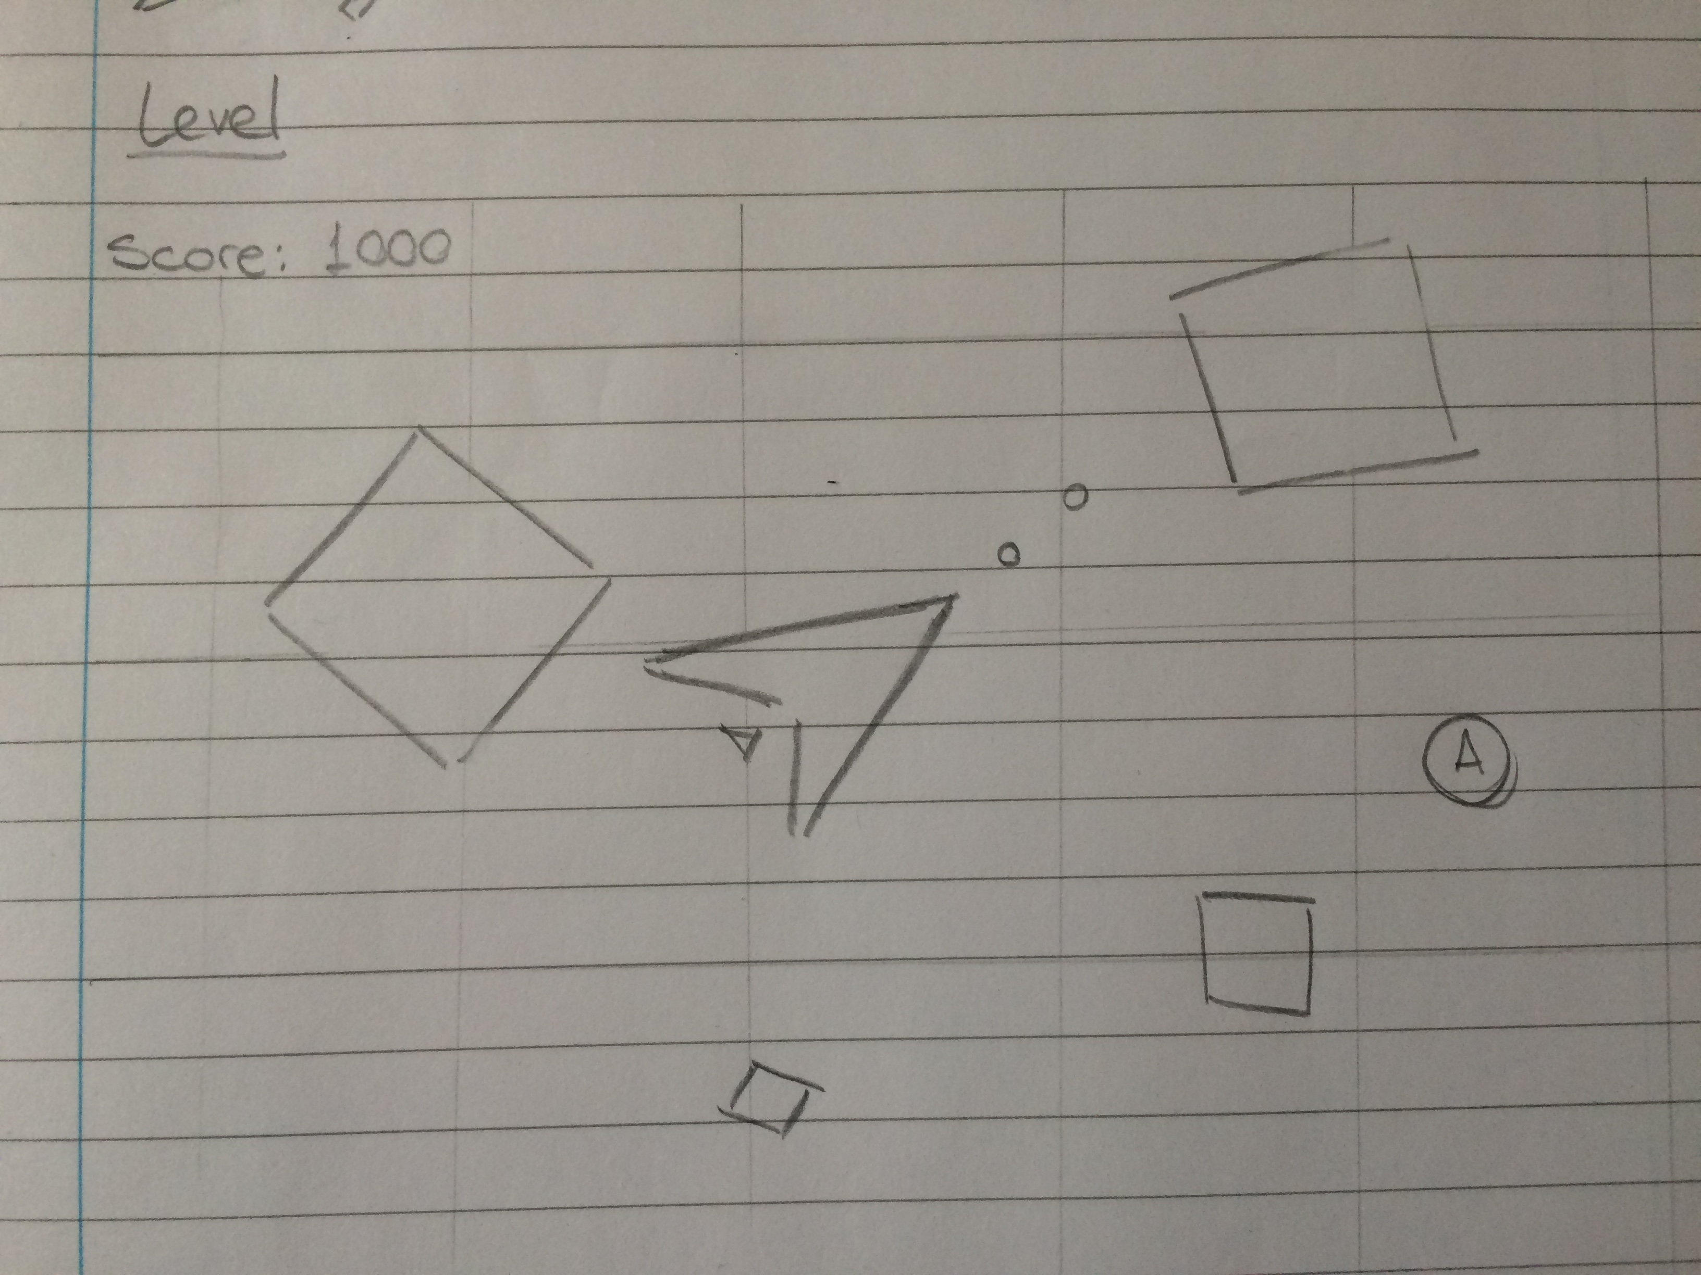
Gameplay

